THE UNIVERSITY OF AZAD JAMMU & KASHMIR, MUZAFFARABAD


COURSE TITLE | DSA
COURSE CODE | CS-2101
LAB TITLE | DOUBLY CIRCULAR LINKED LIST
STUDENT NAME | HASEEB SHEIKH
STUDENT ROLL NUMBER | 2024-SE-31
INSTRUCTOR NAME | ENGR. SIDRA RAFIQUE
SUBMISSION DATE | NOVEMBER 28, 2025

DEPARTMENT OF SOFTWARE ENGINEERING
DSA
Lab 5

Objective:
The primary objective of this lab is to design, implement, and verify a Doubly Circular Linked List (DCLL) using C++ classes.

Node & Class Structure:
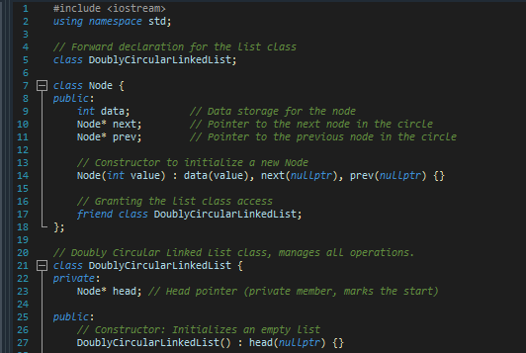

Explanation:

Section | Explanation
Node Class | Defines the list element with data, next, and prev pointers; uses a constructor to initialize values.
DoublyCircularLinkedList Class | The container class that manages the list structure using a private head pointer and provides a constructor to initialize the list as empty.

Inserting a node at the End of the list
- Code

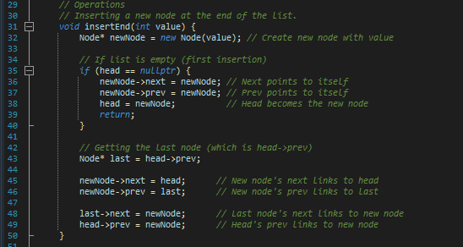

Explanation:

Case | Lines | Action and Explanation
Case 1: Empty List | Lines 34-40 | If head is null, the new node becomes the head. It points its next and prev to itself to form the initial single-node circle.
Case 2: Non-Empty List | Lines 42-49 | The new node is inserted between the existing head and the current last node (head->prev). Four pointers are updated to reconnect the circle: the new node's links, the head's prev, and the old last node's next.

- Main Function



Displaying the list in forward Direction
- Code

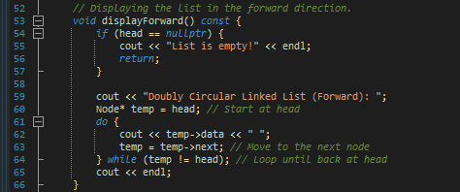

Displaying the list in Backward Direction
- Code

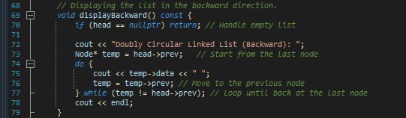

- Output
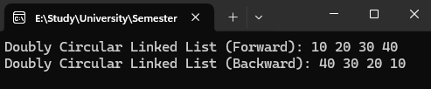

- Main Function
